***NAME : Himanshu Dixit***

***ENROLL NO. : 21103262***

***BATCH : B10***

***Software Development fundamentals-2 [EVEN 2022]***

***Tutorial Sheet -4 (Week 4)***

***Q1.****Define a class TravelPlan in C++ with the following descriptions:*

*Private Members:*

*• PlanCode of type long*

*• Place of type character array (string)*

*• Number_of_travellers of type integer*

*• Number_of_buses of type integer*

*Public Members:*

*A constructor to assign initial values of PlanCode as 1001, place as "Agra", Number_of_travellers as 5, Number_of_buses as 1.*

*A function NewPlan() which allows user to enter PlanCode, Place and Number_of_travellers. Also, assign the value of Number_of_buses as per the following conditions:*

***Number_of_travellers Number_of_buses*** *Less than 20 1*

*Equal to or more than 20 and less than 40 2*

*Equal to 40 or more than 40 3*

*A function ShowPlan() to display the content of all the data members on screen.*

***Solution:***

#include <iostream>

using namespace std;

class TravelPlan

{

long PlanCode;

string place;

int Numberoftravellers;

int Numberofbuses;

public:

TravelPlan()

{

PlanCode=1001;

place="Agra";

Numberoftravellers=5;

Numberofbuses=1;

}

void NewPlan()

{

cout<<"Enter the PlanCode : ";

cin>>PlanCode;

cin.ignore();

cout<<"Enter the place : ";

getline(cin,place);

cout<<"Enter the Number of travellers : ";

cin>>Numberoftravellers;

if(Numberoftravellers<20)

Numberofbuses=1;

else if(Numberoftravellers<40)

Numberofbuses=2;

else

Numberofbuses=3;

}

void ShowPlan()

{

cout<<"\nPlanCode : "<<PlanCode;

cout<<"\nPlace : "<<place;

cout<<"\nNumber of travellers : "<<Numberoftravellers;

cout<<"\nNumber of buses : "<<Numberofbuses;

}

};

int main()

{

TravelPlan T;

T.NewPlan();

T.ShowPlan();

return 0;

}

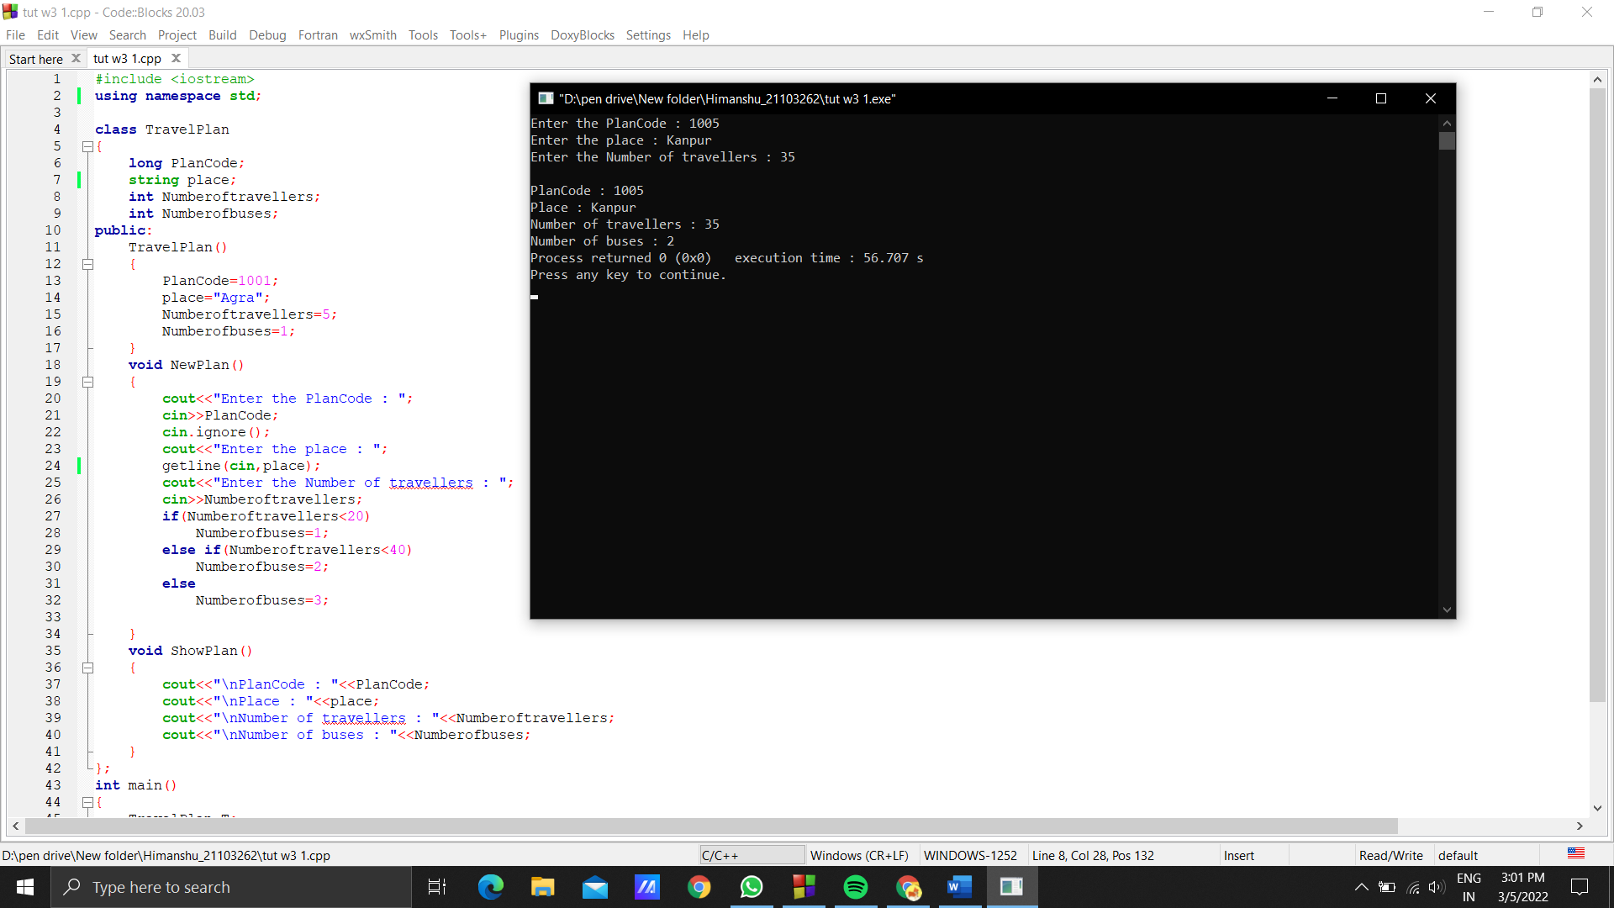

***Q2.*** *Explain the role of a default constructor? When is it considered equivalent to a parameterized constructor? Support your answer with examples.*

***Solution:***

Default constructor is used to assign default values of parameters in class. It is equivalent to parameterized constructor when parameters is passed at the time of object calling.

Class ABC

{

public:

ABC() //Default constructor

{

}

};

Int main()

{

ABC a;

}

Class ABC

{

public:

ABC(int a) //parametrize constructor

{

}

};

Int main()

{

ABC a(3);

}

***Q3.*** *What is a parameterized constructor? How is it useful?*

***Solution:***

Parameterized constructor is the constructor which has parameter at the time of declaration.

Is it useful at that time when we have to initialized some values other than default.

***Q4.*** *What will be the output of following program? Explain with reasons:*

*#include<iostream.h>*

*class student{*

*int rollno;*

*char grade;*

*static int count;*

*public:*

*student()*

*{*

*rollno=0; grade=' ';*

*cout<<"Creating object"<<++count<<"\n"; }*

*void init(void)*

*{*

*cout<<"\n Enter rollo and grade :";*

*cin>>rollno>>grade;*

*cout<<"\n";*

*}*

*~student()*

*{*

*cout<<"Destroying object"<<--count<<"\n"; }*

*};*

*int student::count=0;*

*int main()*

*{*

*student classes[5];*

*for(int i=0;i<5;i++)*

*{*

*cout<<"\n Enter details for student"<<i+1<<"\n"; classes[i].init();*

*}*

*return 0;*

*}*

***Solution:***

Output :

Creating object1

Creating object2

Creating object3

Creating object4

Creating object5

Enter details for student1

Enter rollo and grade :1 A

Enter details for student2

Enter rollo and grade :2 B

Enter details for student3

Enter rollo and grade :3 A

Enter details for student4

Enter rollo and grade :4 C

Enter details for student5

Enter rollo and grade :5 A

Destroying object4

Destroying object3

Destroying object2

Destroying object1

Destroying object0

Reason:

At the time of object array constructor calls 5 times then enter the details and it will print details and then destructor calls 5 times.